PIN CONFIGURATIONS
PIN-OUT FINGERPRINT AS608 into ESP32 38PINS BOARD
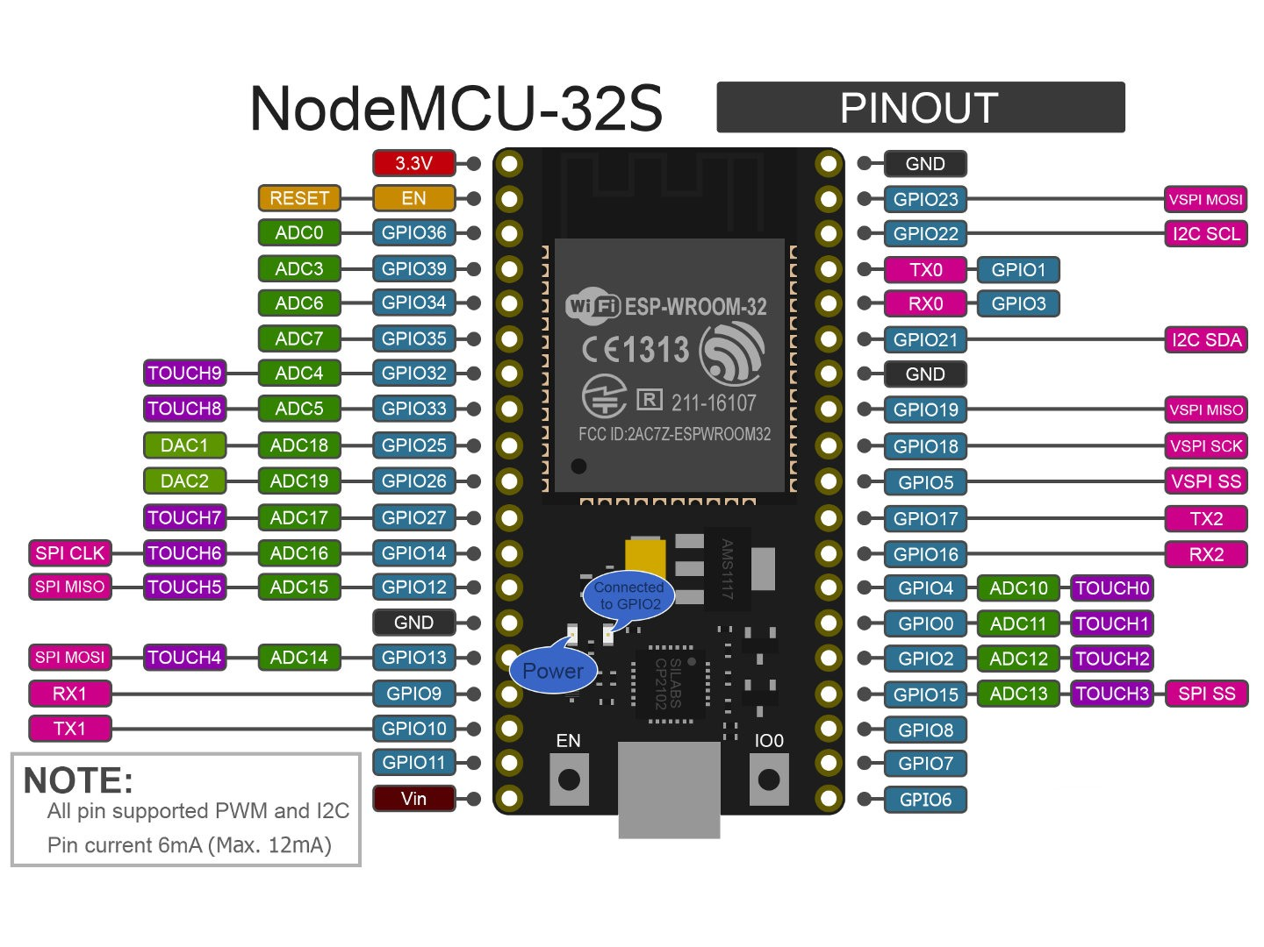
AS608 Fingerprint
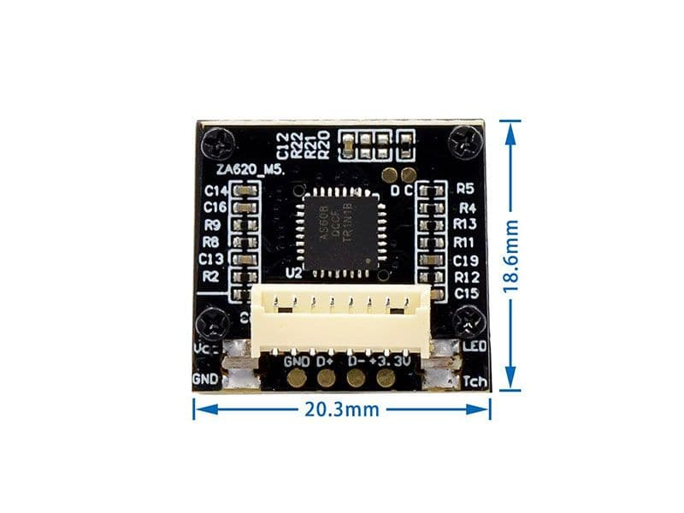

PINOUT AS608 to ESP32 38 PINS BOARD
YELLOW VCC – 3.3V POWER PIN 1
GREEN RX – GPIO 16 PIN 27
WHITE TX – GPIO 17 PIN 28
BLACK GROUND – GROUND PIN 14

PIN-OUT for Sensors: Humidity, Temperature, Light, Motion

PIR HC-SR501
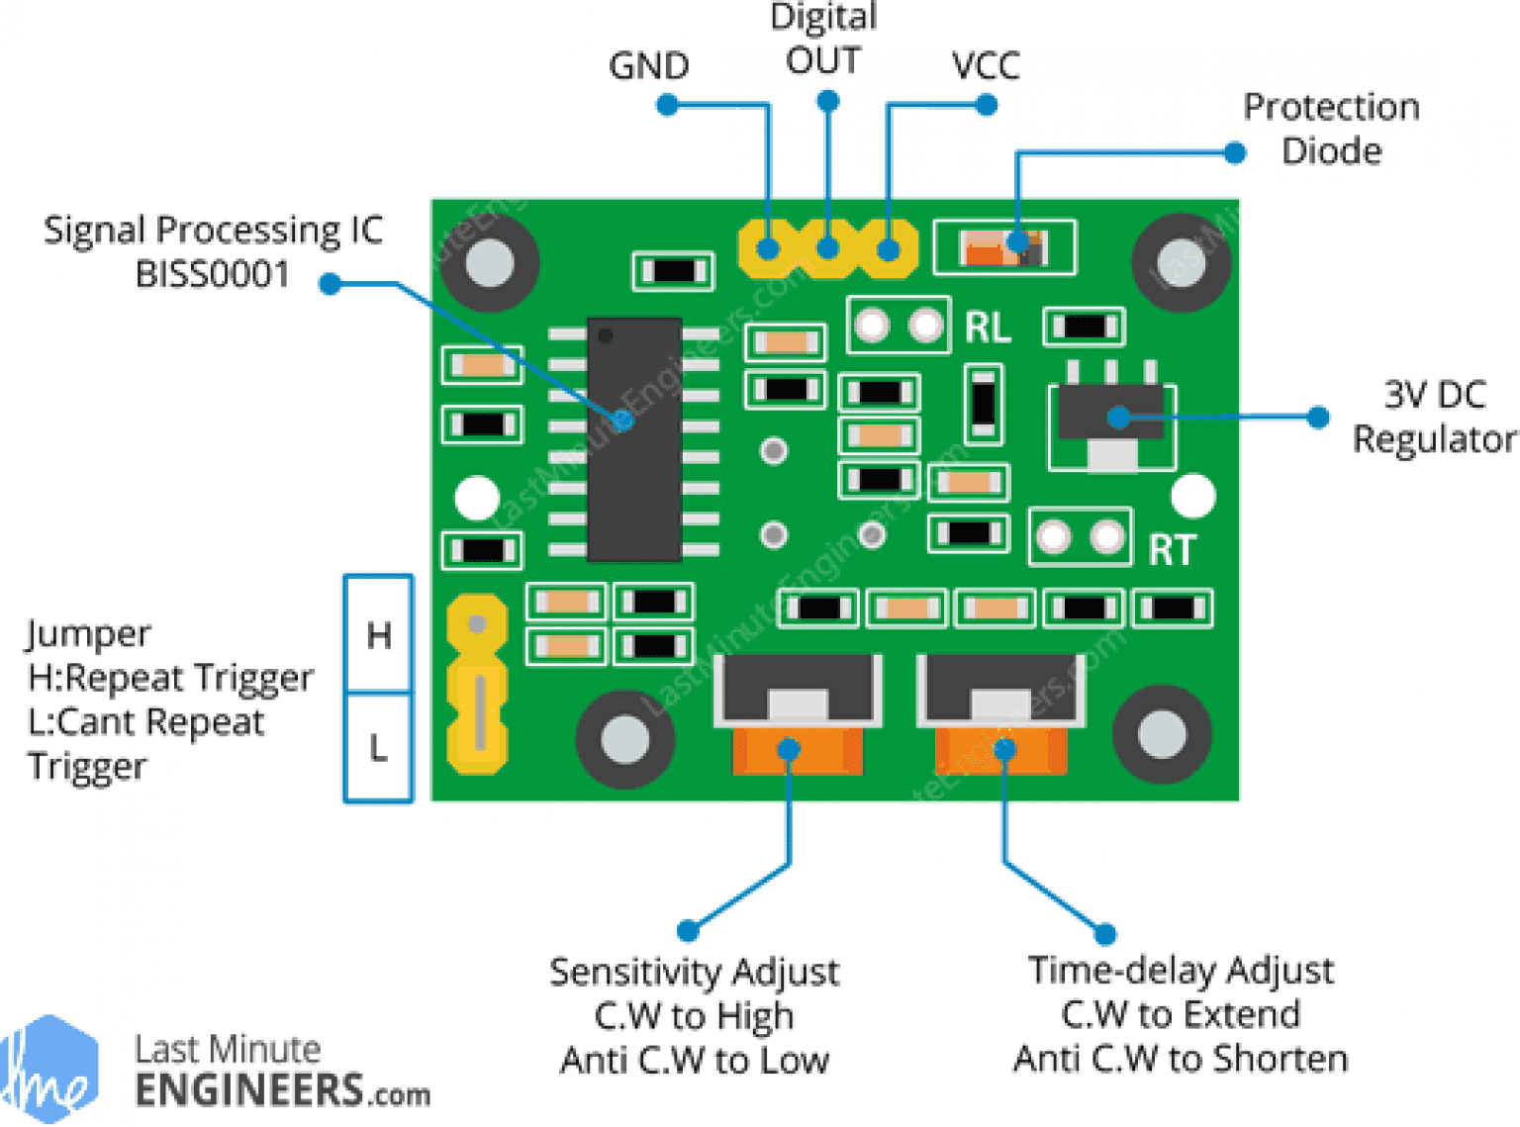

PINOUT HC-SR501 into ESP32 38 PINS BOARD
GND – GROUND PIN 14
DIGITAL OUT – GPIO 25 PIN 9
VCC – 3.3V POWER PIN 1

DHT-11
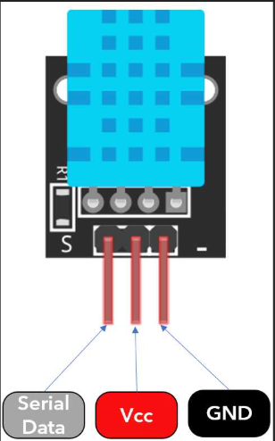

PINOUT DHT 11 into ESP32 38 PINS BOARD
SERIAL DATA – GPIO 26 PIN 10
VCC – 3.3V POWER PIN 1
GND – GROUND PIN 14

DFRobot Ambient Light Sensor
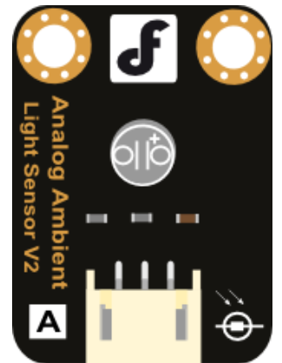

BLACK GROUND – GROUND PIN 14
RED VCC – 3.3V POWER PIN 1
BLUE DATA – PIN 3 GPIO 36
NOTE:
JUMP Wires of PIN 1 Power and PIN 14 Ground

